1. **Title: CommUnity: Seamless Community Interaction and Management**

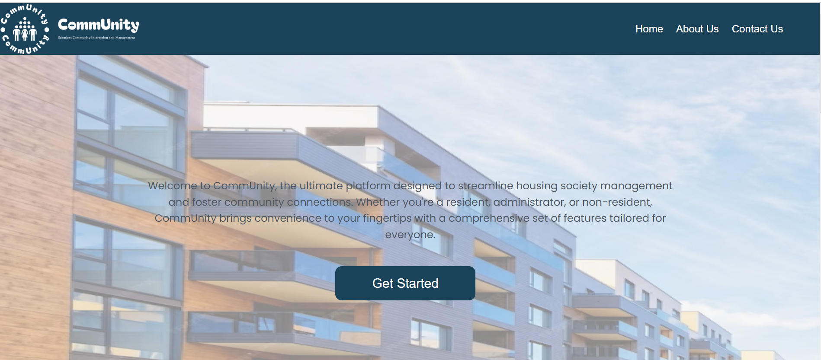

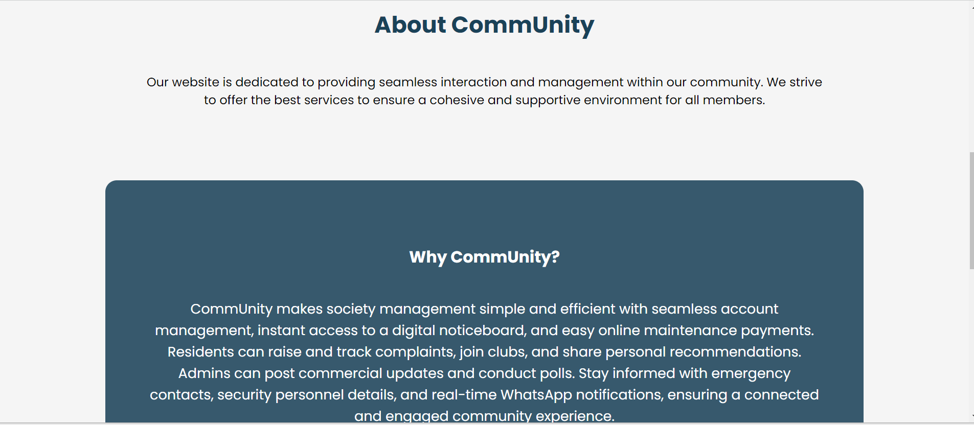

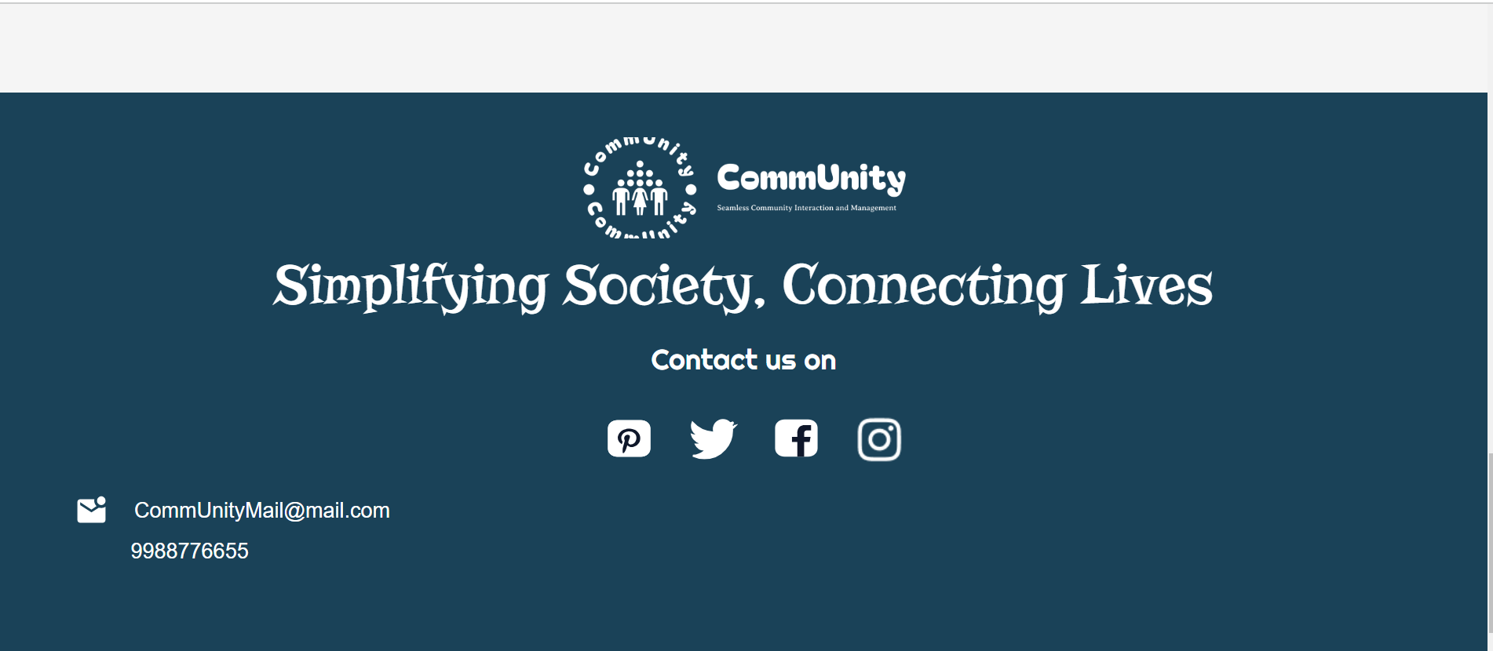

1. **Project Statement:**

CommUnity is a modular, multi-tenant Community Management System designed to simplify housing society management by connecting members and streamlining daily activities. The platform provides an efficient interface for both administrators and residents, facilitating interaction, management, and engagement within the community.

**Outcomes:**

* Provide a platform that simplifies housing society management and enhances communication between residents and administrators.
* Increase resident participation in community activities through events, polls, clubs, and social interactions.
* Facilitate transparent financial transactions with easy bill generation, online payments, and payment tracking.
* Ensure easy access to emergency contacts and security personnel information, enhancing the overall safety and security within the community.

1. **Modules to be implemented**
2. User Authentication and Registration
3. Resident and Society Management
4. Event and Notice Management
5. Complaint and Service Request Management
6. Maintenance Payment System
7. **Week-wise module implementation and high-level requirements with output screenshots**

**Milestone 1: Weeks 1-2**

**Module 1: User Authentication and Registration**

* Implement user registration functionality.
* Develop a user login mechanism using JWT-based authentication.
* Integrate profile management for residents and admins.
* Output Screenshot: (User Login and Registration Page)

**User Registration**

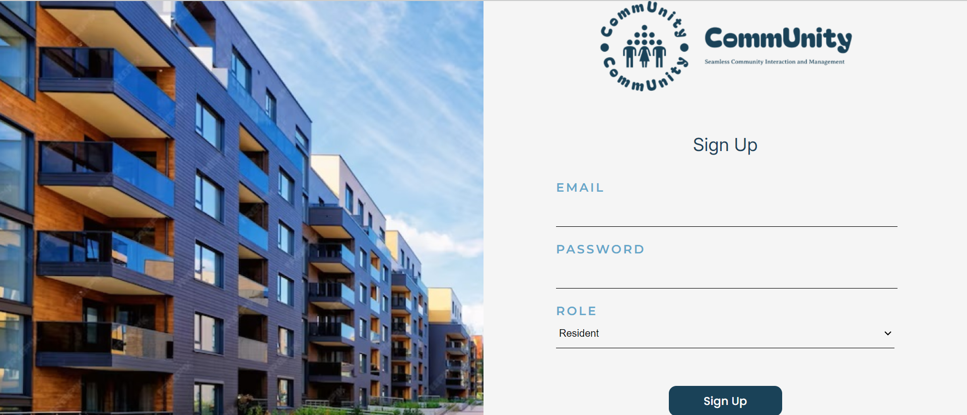

**User Login**

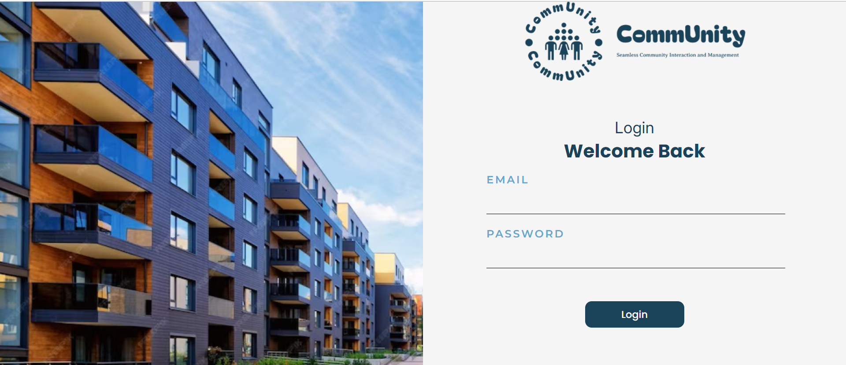

**Details to be filled by the admin when he logins for the first time**

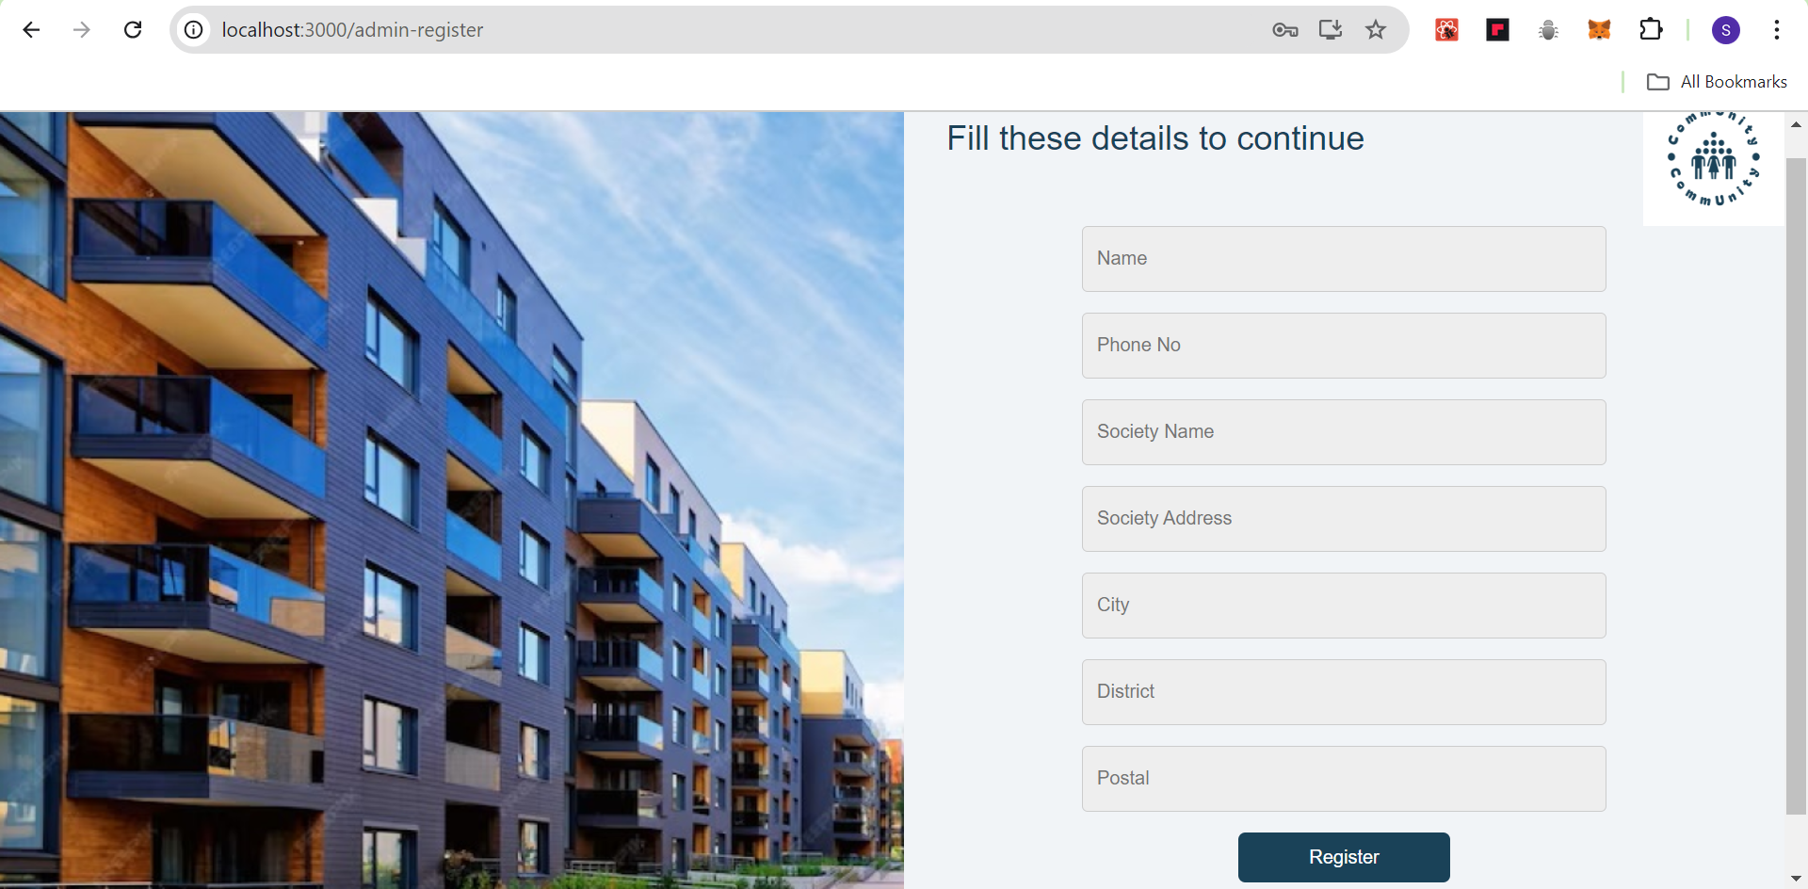

**Details to be filled by the User when he logins for the first time**

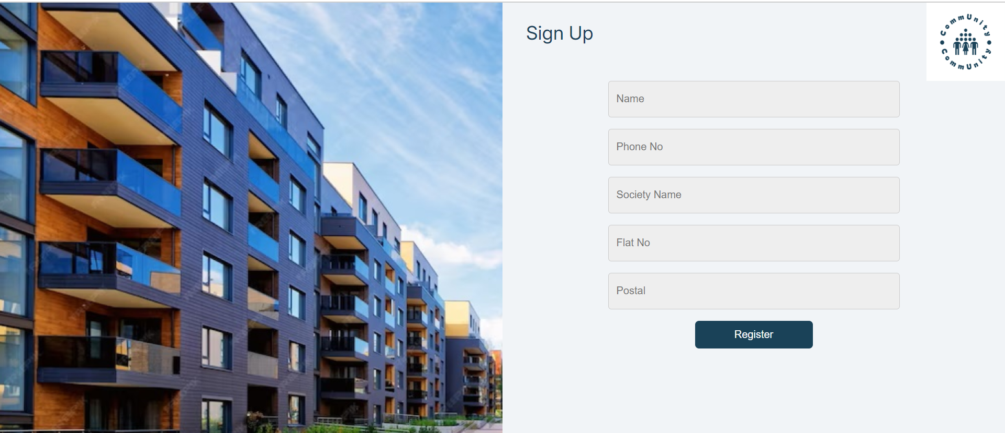

**Milestone 2: Weeks 3-4**

**Module 2: Resident and Society Management**

* Design the database schema for society, flat, and resident information.
* Develop a service for society admins to add and update resident details.
* Implement functionality to manage flats, residents, and their association with societies.
* Output Screenshot:

**Residents of the society**

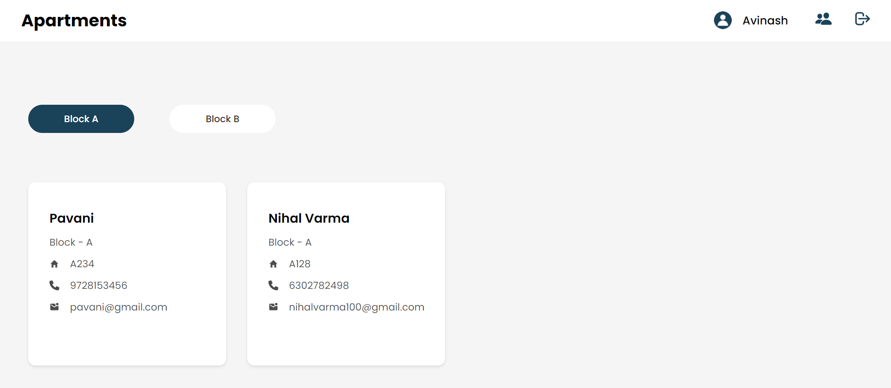

**User Profile**

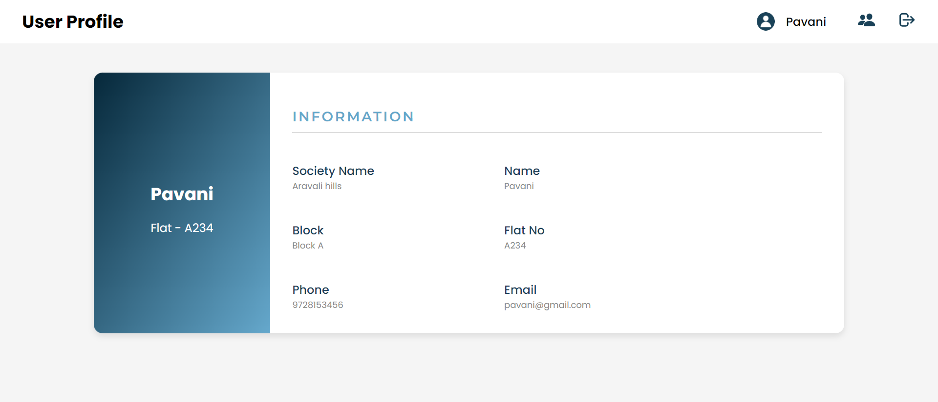

**Milestone 3: Weeks 5-8**

**Module 3: Event and Notice Management**

* Design and implement an interface for admins to post events, notices, and circulars.
* Residents should be able to view and provide feedback to the events.
* Output Screenshot:

**Admin can add update and delete Events.**

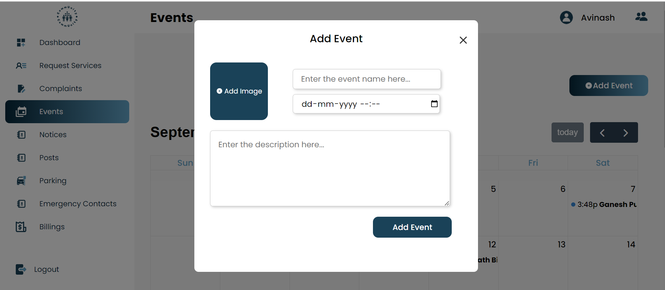

**Users can give feedback to the events**

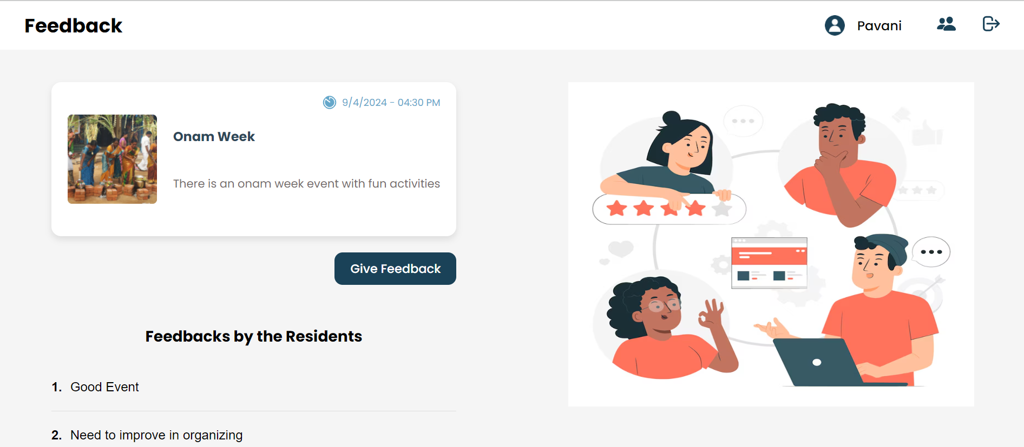

**Admin can add update and delete Notices.**

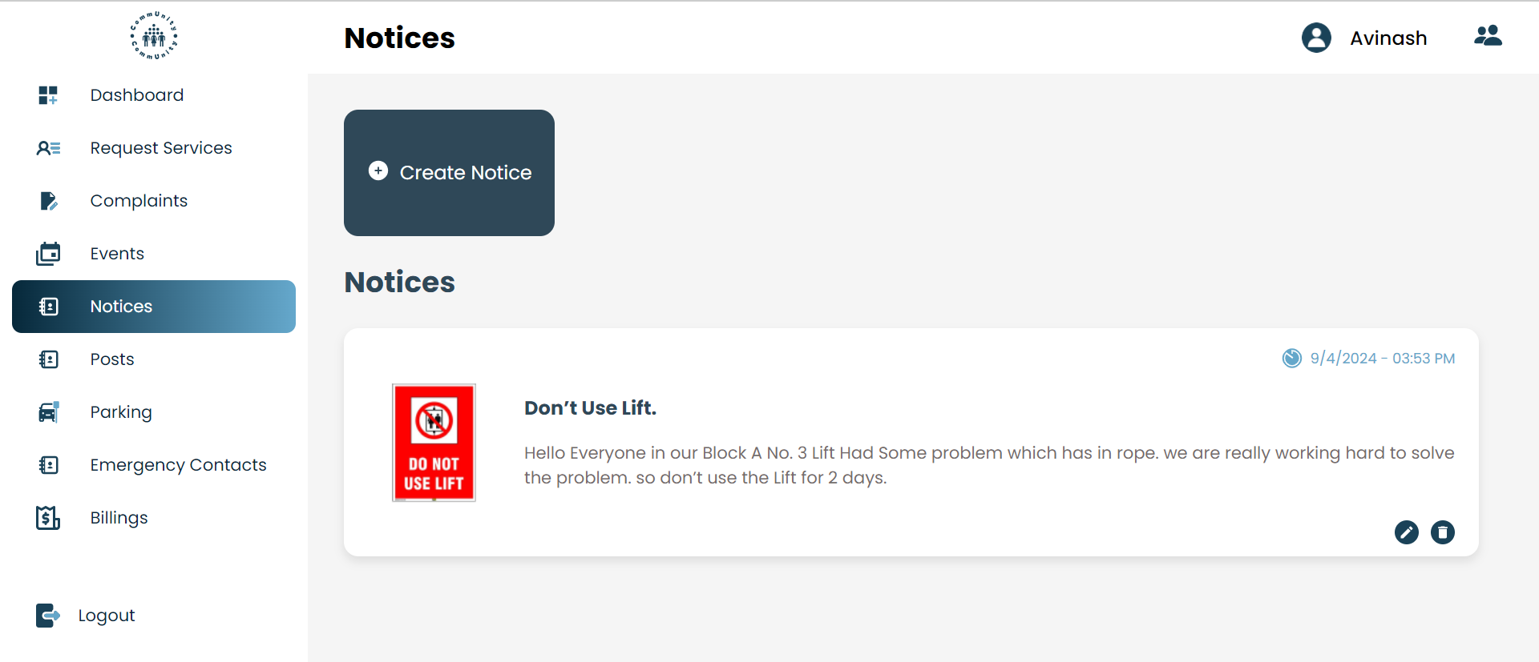

**Module 4: Complaint and Service Request Management**

* Design a complaint and service request interface for residents to log issues and service requests.
* Develop backend functionality to track complaints, their statuses, and assigned vendors.
* Residents should be able to view the status of their requests.
* Admins can monitor and close tickets.
* Output Screenshot:

**User can request the services**

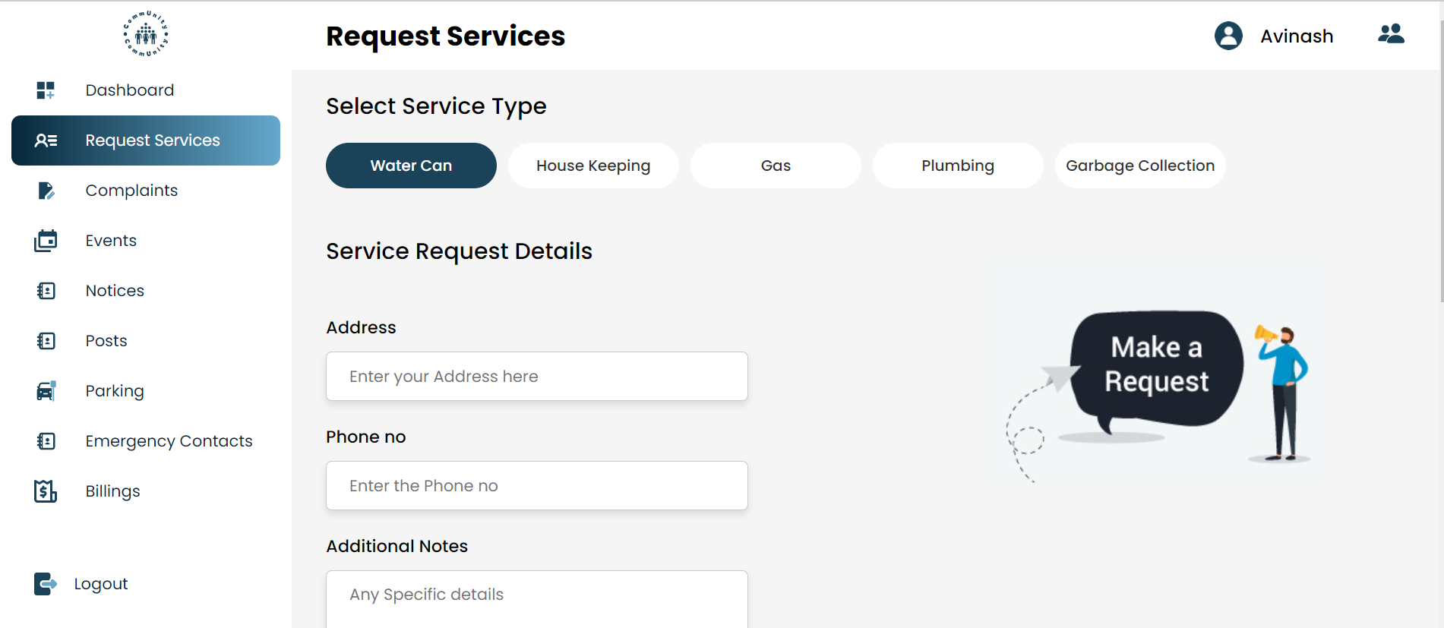

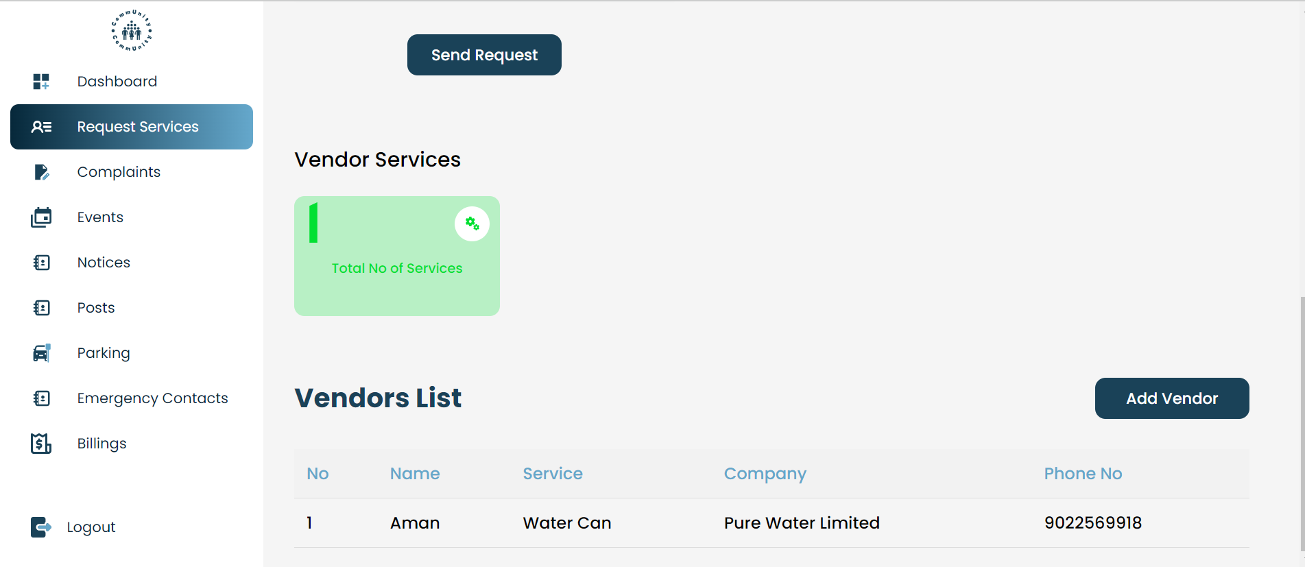

**Admin can see the complaints**

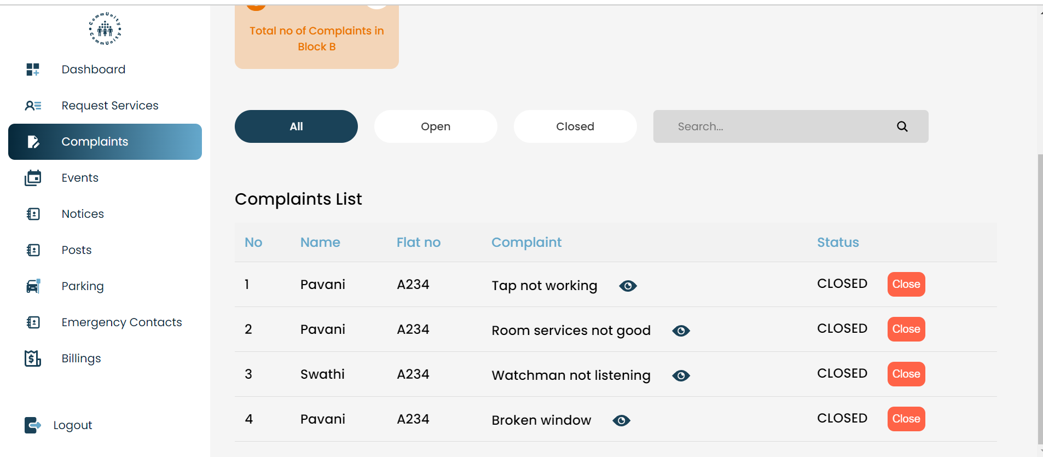

**User can file a complaint**

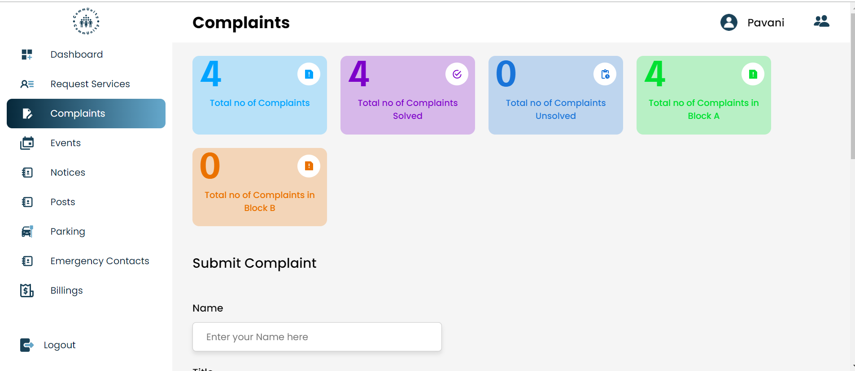

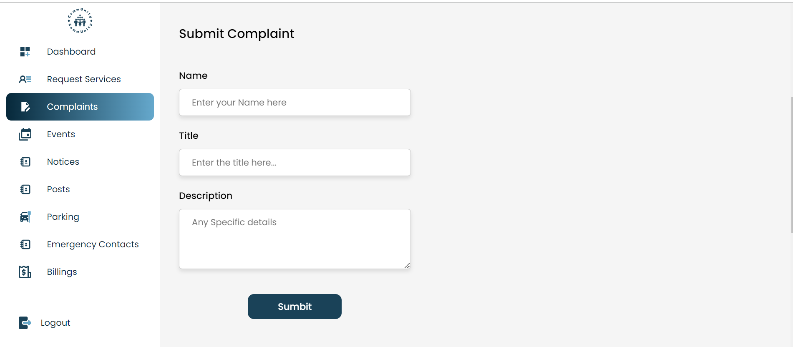

**Milestone 4: Weeks 9-10**

**Module 5: Maintenance Payment System**

* Integrate Razorpay API for online payment of monthly maintenance bills.
* Implement backend logic to generate monthly bills and store payment details.
* Develop an interface for residents to pay maintenance fees and view payment history.
* Admin should be able to track who has paid and who is pending.
* Output Screenshot:

**Admin can see the payment status of the residents**

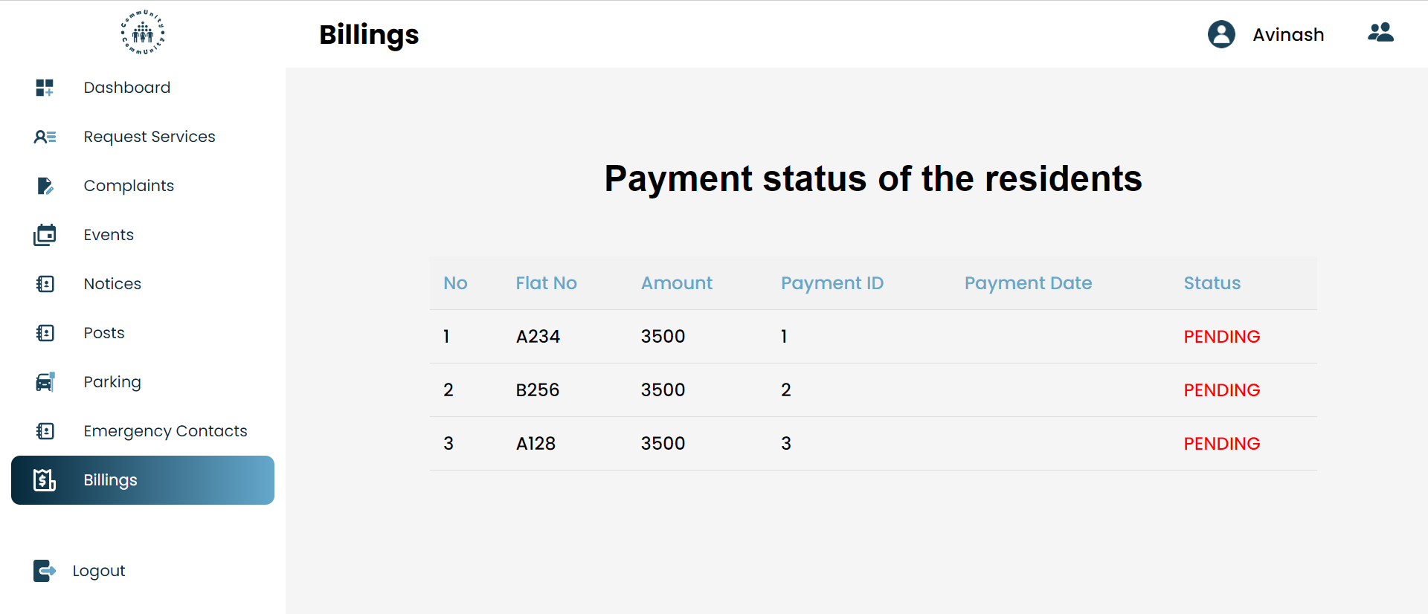

**User should be able to pay the monthly maintenance bill**

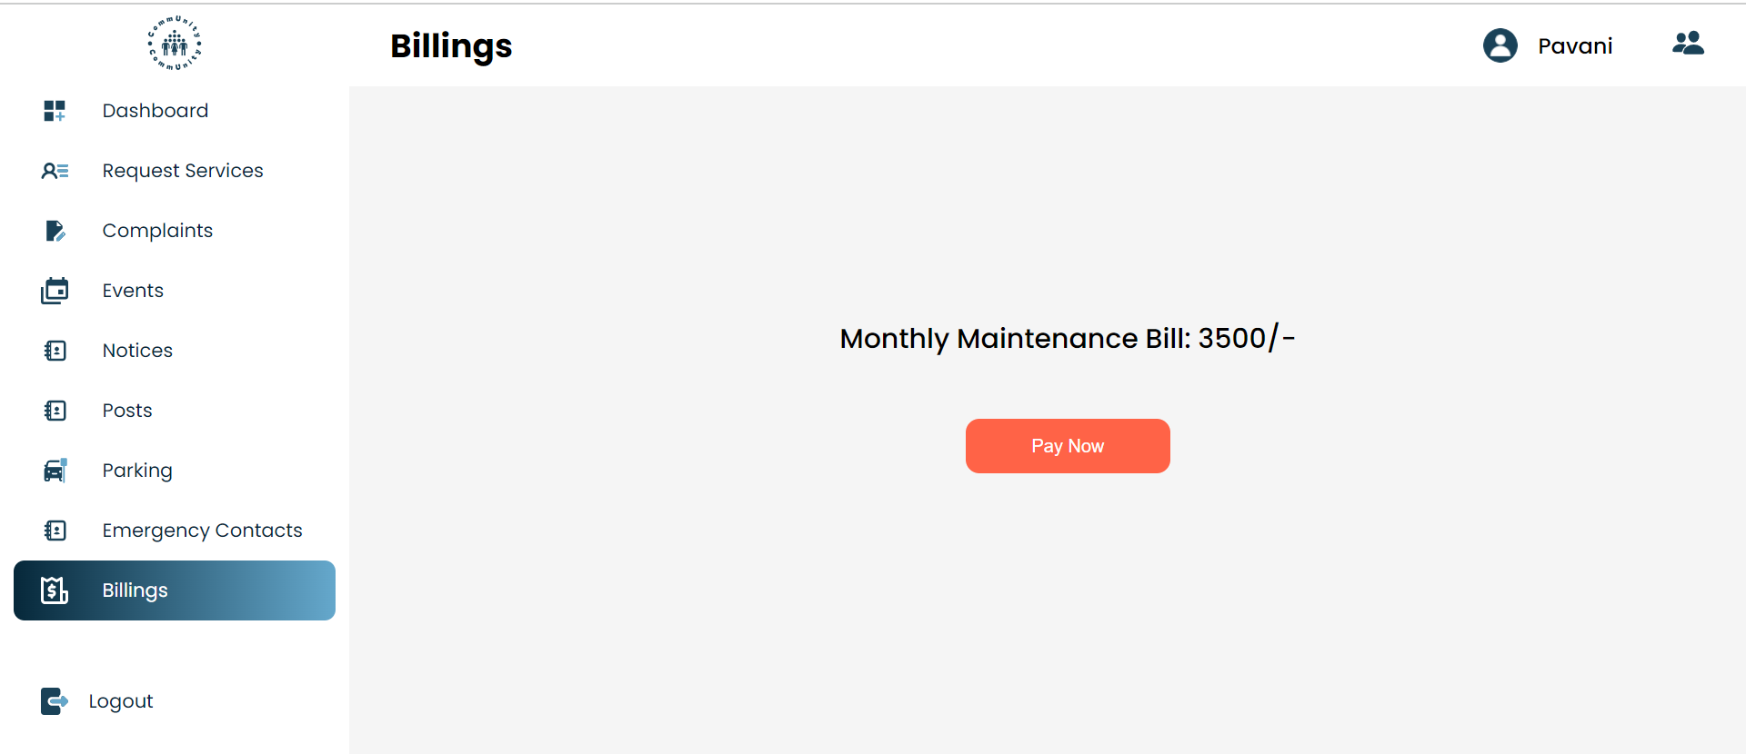

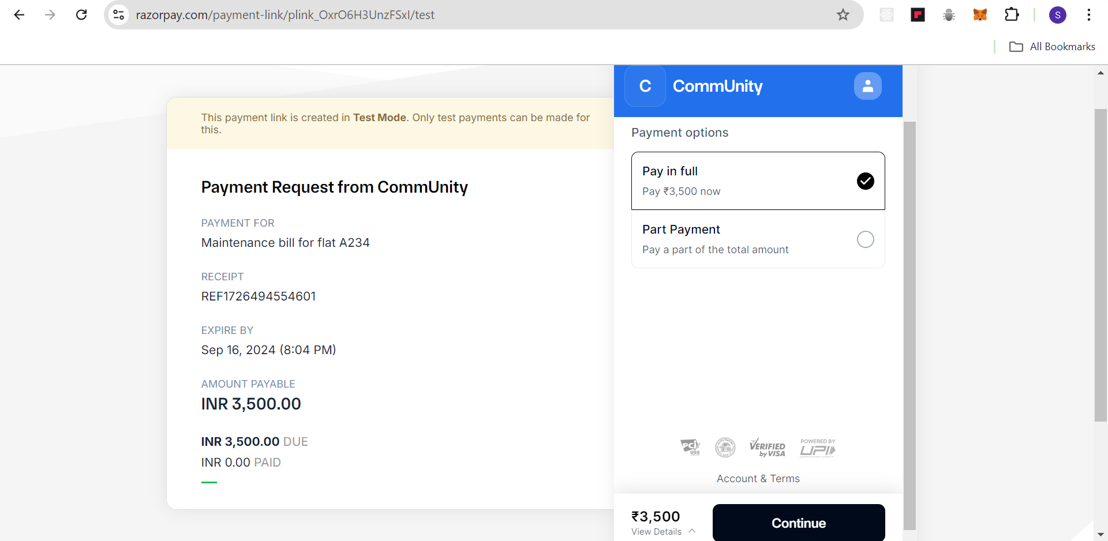

**Evaluation Criteria:**

**Milestone 1 Evaluation (Week 2):**

* Successful implementation of user authentication and registration.
* Both admins and the residents are able to login and register themselves.

**Milestone 2 Evaluation (Week 4):**

* Successfully implemented the society management module.
* All the residents and their information is getting stored in their respective societies.

**Milestone 3 Evaluation (Week 8):**

* Event and Notice management implemented, where the residents can get information about all the events and any urgent notice.
* Implemented with the user feedback functionality.

**Milestone 4 Evaluation (Week 10):**

* Razorpay integration and fully functional payment interface for residents.
* Admin payment interface also implemented where the admin can view the details of the payment history.

1. **Design diagrams**

Architecture Diagram:

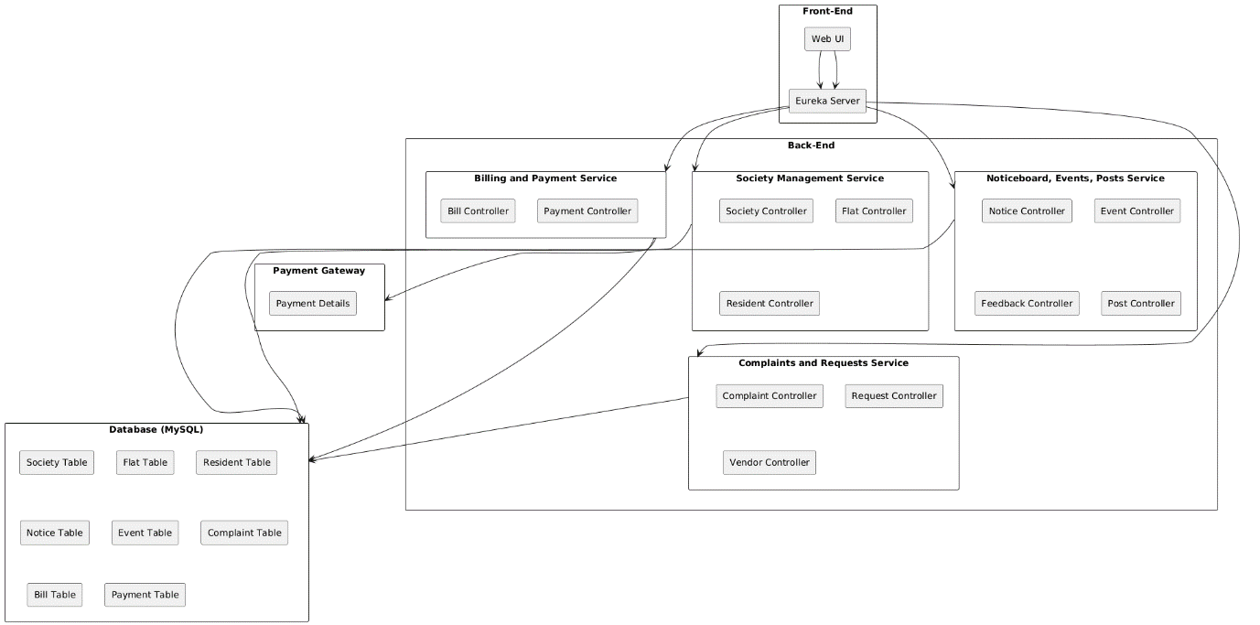

Database Schema:

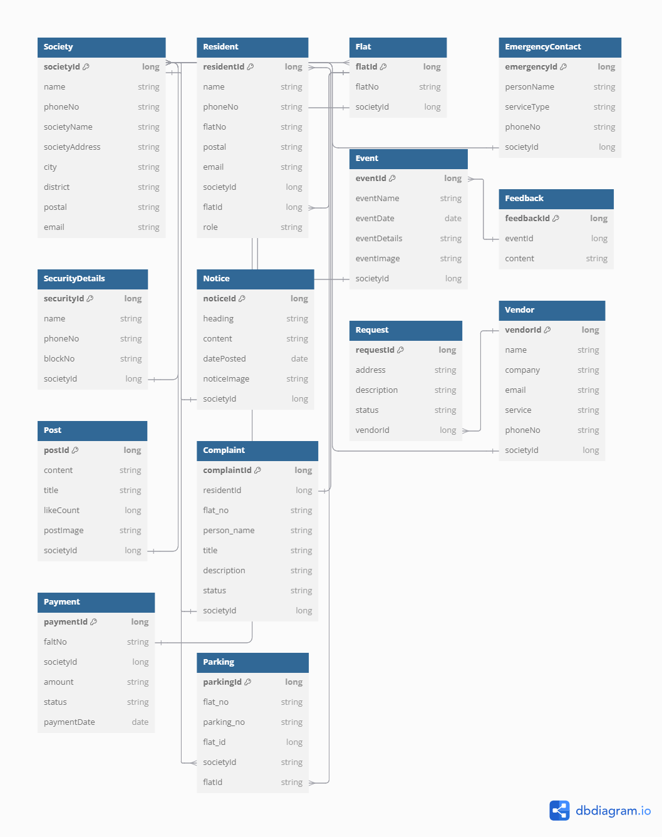

Workflow Diagram:

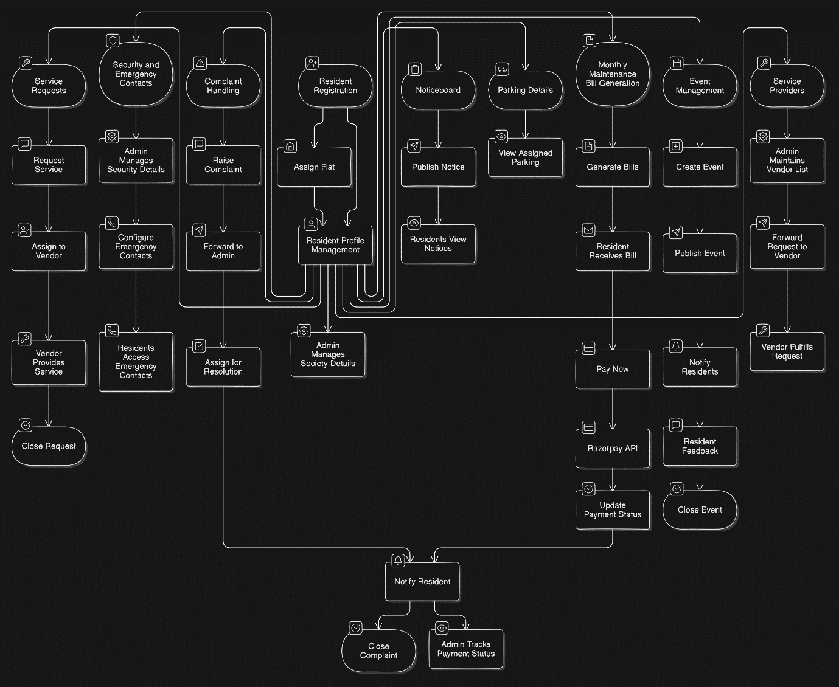

**Output Screenshots:**

1. Dashboard

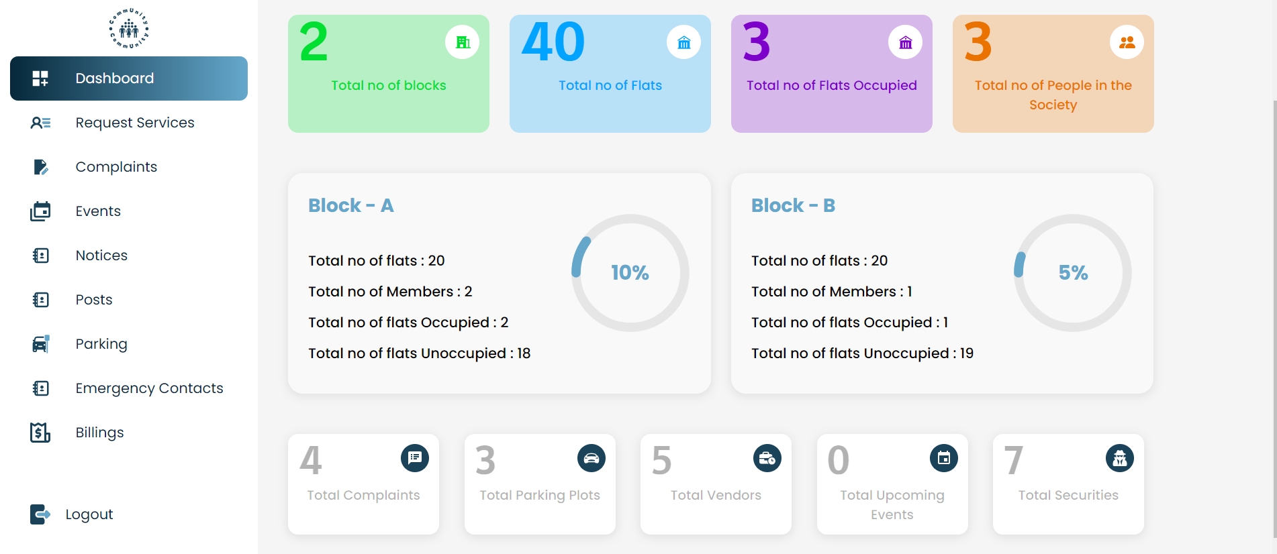

2. Parking Lots

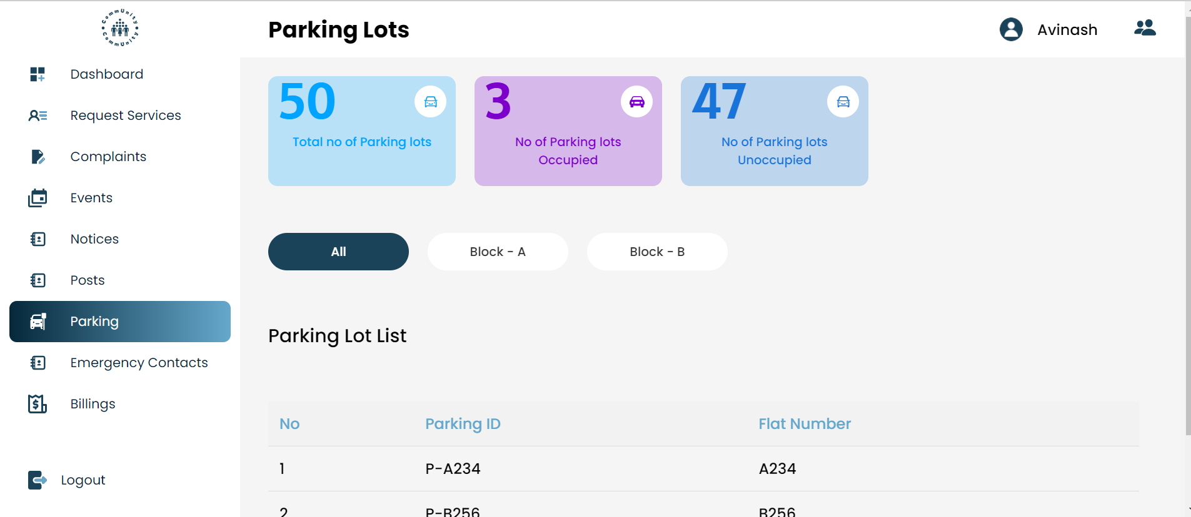

3.Security Guard details

